Instructions for Setting Up and Operating Firebird-v63H04_H_Ashi_Trend_vs1_5b

Version
Version “Firebird-v63H04_H_Ashi_Trend_vs1_5b” is the latest version found on the Forex Factory thread “Semi automatic EA (Driven Version)” started by SamuraiPower. It is not clear what the sections of the name mean:
Firebird – Name of Expert Advisor (EA)
v63H04 - ???
H_Ashi_Trend – Heiken Ashi Trend Indicator (HA) is used to determine long term trend
vs_1_5b – Version 1.5b is the latest version

How the Code Works
Firebird-v63H04_H_Ashi_Trend_vs1_5b is a fully automated code set regarding entry and exit points but does require the manual placement and naming of an up or down trend line.
Entry Conditions
Entry conditions are created by a 10 bar Moving Average (MA). If the market crosses the 10 MA and is the direction of the HA indicator, a trade will initiate.
Exit Conditions
Exit conditions are triggered by a Take Profit (TP) of 100 pips, Stop Loss (SL) of 300 pips, and a Trailing Stop (TS) of 40 pips after a positive position of 20 pips has triggered.
Further Entry Conditions
If trading goes against the system by 40 pips, an additional position will be taken in the direction of the HA indicator. This will occur every 40 pips until a maximum of 5 positions are in place or until the market crosses the manually place Trend Line (TL).

How to Set Up the Firebird Expert Advisor

Broker
Your broker must offer the MetaTrader 4.0 trading platform. Please note that IBFX calls their platform Interbank FX 4 as it is a clone of MetaTrader. When setting up this account, be sure to note which size trading account you have selected. For example, IBFX offers a standard lot size account of $100,000 and a mini-lot size of $10,000. If a mini-lot size account is selected, the trading will be one tenth the size of most others on the forum. For example, a TP of 100 pips will be worth $10, not $100.
Another point to consider about your broker is the displayed accuracy of the data stream. For most currency pairs, the data will display to the fourth or fifth decimal place. Firebird is defaulted to work with five decimal places but can be adjusted for four decimal places.
At this point, the broker should allow you access to download and install MetaTrader.

Configuring Firebird
It is assumed that Firebird is loaded onto the MetaTrader platform on a daily (D1) chart. Be sure to allow live trading by clicking F7, Common, and selecting “Allow live trading”. A smiley face () should now be seen in the upper right hand corner of the plot. If no new data is available, the upper left hand corner will say “Init”. If data is available, it will say “Waiting for Main trend”.

Main trend line
“Waiting for Main trend” is referring to a manual trend line that needs to be added before the EA will function. Create this line as a normal trend line. Select the line by right clicking it. Select Trendline properties…, and Common. In the Description field enter “Main_UpTrend_Alert_” if the trend line is going up and “Main_DownTrend_Alert_” if the trend line is going down. Firebird will look for the word “Main” so that it knows where to stop trading. It will also look for “UpTrend” or “DownTrend” so it knows which direction to take the next position.
If the market should cross this trend line, the EA will stop taking new trades until a new trend line is created and named. The trend line will automatically have its description shortened such that it is no longer valid.
The trend line should be placed such that it looks like a support or resistance line. If the market is trending up, then the trend line should be under the price action and similarly for a market trending down.

Software Variables
When Firebird is loaded onto MetaTrade, Firebird will bring with it a set of variables that will function properly provided the broker’s data is in a five decimal format and that the account is set up to trade standard size ($100,000) lots. If the trading account is set up as a non-standard size, (mini, micro, nano) then the profit or loss from each trade will be smaller by a factor or 10, 100, or 1000.
For those accounts created at brokers who use a four decimal place format, some of the Firebird’s variables will need to be divided by a factor of 10. Those variables are marked with a red sun in the table below.

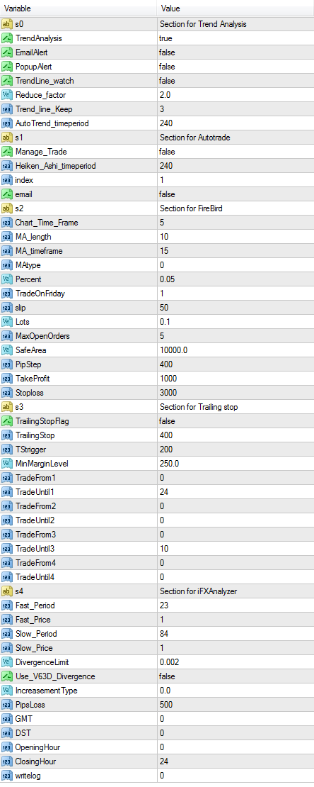
NOTES:
Will send Email notification if HA has changed directions
Divides Stop Loss by this amount after market crosses trend line
Firebird will run on a 5 minute interval even though chart is a 1 hour
Moving Average is based on these number of bars
Set to zero for a Simple Moving Average (SMA)
1 will trade on Friday. Other than 1 will not trade on Friday
Assumed amount of slippage between calculated and actual position
Adjust the amount of exposure from each trade
Firebird will not more than these number of positions
If market goes against the position by this amount, another position will be taken
Trade will exit after this number of pips of profit
Trade will exit after this number of pips of loss
Trade will exit after this number of pips of loss….
…..after there is this amount of profit

